Clean Code Principles - Keep Framework Code Separate
# Source: AI Source: Provided by: [Data Path: Persons Table -> ID Column: 1, Name_En Column: Motasem Essam] -> From: [Chatgpt (GPT‑5 Mini)] on [12/9/2025]
This principle means you should separate your business logic from framework-specific code (like Spring, Django, Express, etc.).
👉 Your core logic should not depend directly on the framework.

🔑 Why It Matters
# Source: AI Source: Provided by: [Data Path: Persons Table -> ID Column: 1, Name_En Column: Motasem Essam] -> From: [Chatgpt (GPT‑5 Mini)] on [12/9/2025]
- Makes code easier to test (without framework)
- Easier to switch frameworks in the future
- Keeps business logic clean and reusable
- Reduces coupling (dependency on external tools)

❌ Bad Example (Tightly Coupled to Framework)
# Source: AI Source: Provided by: [Data Path: Persons Table -> ID Column: 1, Name_En Column: Motasem Essam] -> From: [Chatgpt (GPT‑5 Mini)] on [12/9/2025]
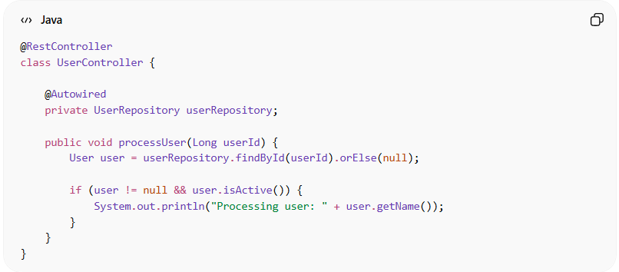
@RestController
class UserController {

@Autowired
private UserRepository userRepository;

public void processUser(Long userId) {
User user = userRepository.findById(userId).orElse(null);

if (user != null && user.isActive()) {
System.out.println("Processing user: " + user.getName());
}
}
}
👉 Problems:
- Business logic is inside a framework class (@RestController)
- Hard to test without Spring
- Tightly coupled to framework annotations and components

✅ Good Example (Separated Logic)
# Source: AI Source: Provided by: [Data Path: Persons Table -> ID Column: 1, Name_En Column: Motasem Essam] -> From: [Chatgpt (GPT‑5 Mini)] on [12/9/2025]
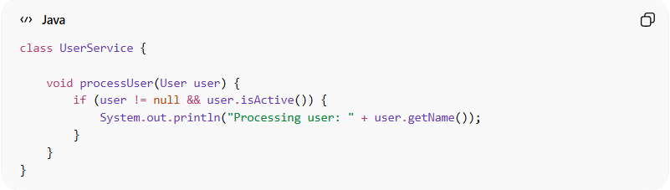
class UserService {

void processUser(User user) {
if (user != null && user.isActive()) {
System.out.println("Processing user: " + user.getName());
}
}
}
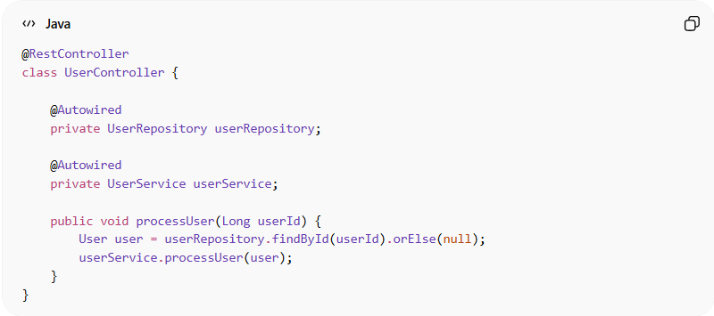
@RestController
class UserController {

@Autowired
private UserRepository userRepository;

@Autowired
private UserService userService;

public void processUser(Long userId) {
User user = userRepository.findById(userId).orElse(null);
userService.processUser(user);
}
}

✅ Even Better (Clean Architecture Style)
# Source: AI Source: Provided by: [Data Path: Persons Table -> ID Column: 1, Name_En Column: Motasem Essam] -> From: [Chatgpt (GPT‑5 Mini)] on [12/9/2025]
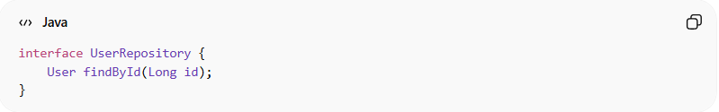
interface UserRepository {
User findById(Long id);
}
👉 Now your business logic depends on an interface, not the framework

💡 Key Idea
# Source: AI Source: Provided by: [Data Path: Persons Table -> ID Column: 1, Name_En Column: Motasem Essam] -> From: [Chatgpt (GPT‑5 Mini)] on [12/9/2025]
Frameworks are tools, not the core of your application.
Keep them at the edges, not in the center of your logic.

🚫 Common Mistakes
# Source: AI Source: Provided by: [Data Path: Persons Table -> ID Column: 1, Name_En Column: Motasem Essam] -> From: [Chatgpt (GPT‑5 Mini)] on [12/9/2025]
- Writing business logic inside controllers
- Using framework annotations everywhere
- Direct dependency on framework classes
- Mixing infrastructure with domain logic

🧾 Summary
# Source: AI Source: Provided by: [Data Path: Persons Table -> ID Column: 1, Name_En Column: Motasem Essam] -> From: [Chatgpt (GPT‑5 Mini)] on [12/9/2025]
Keeping framework code separate helps you:
- Write clean, testable, and reusable code
- Reduce dependency on frameworks
- Build flexible and maintainable systems

